**Arjay**

**Inhabitants and Supernatural Elements :**

The population of Biringan, according to local folklore, comprises supernatural beings known as "Engkantos" ("enchanted beings") and their hybrid offspring with humans. These engkantos are characterized as shapeshifters capable of assuming human form, though in their human disguise, they supposedly lack a philtrum—the vertical groove between the nose and upper lip—marking them as non-human entities walking among regular people. This distinctive physical characteristic serves as a recognition feature in various Philippine folkloric traditions, allowing the observant to identify supernatural beings masquerading as humans.

Different accounts offer varying physical descriptions of these mystical inhabitants. Some narratives portray them as resembling handsome or beautiful elvish beings, while others suggest they appear more like dwarves or "Duwendes"—small supernatural entities common in Filipino folklore. Regardless of their specific appearance, these supernatural residents represent a powerful parallel society with abilities and technologies beyond human understanding. The city is also rumored to contain vast treasures of gold, adding material allure to its supernatural mystique.

**Biringan City's Appearance and Access:**

Descriptions of Biringan City paint an image of an ultramodern metropolis with architecture and technology far exceeding contemporary human capabilities. Those who claim to have glimpsed the city describe high-rise buildings, splendid houses, and futuristic technology that surpasses even the most advanced science fiction representations. Some accounts characterize it as a black urban cityscape dominated by spires and cathedrals rather than conventional skyscrapers, with an architectural magnificence that outshines global megacities like New York or Hong Kong. The phantom city manifests primarily as a "dazzling city of light" visible to seafarers during moonless nights, appearing briefly before vanishing once again into the metaphysical realm.

The phantom city is said to be inaccessible through conventional means, requiring supernatural guidance or special spiritual gifts to enter. According to legends, seven portals or waypoints leading to the city are scattered across Samar island. One such portal is allegedly located at an ancient tree within the campus of Northwest Samar State University in Calbayog. These access points represent threshold spaces between the natural and supernatural worlds, allowing passage between realms under specific circumstances or with particular guidance. The concept of limited accessibility enhances Biringan's mystique, explaining why concrete evidence of its existence remains elusive while allowing for continued belief in its reality.

References:

https://en.wikipedia.org/wiki/Biringan

http://www.esquiremag.ph/long-reads/features/creepy-legend-biringan-city-a00293-20191222

https://zine.ph/legends/biringan-and-other-hidden-cities/

**Mark**

Habang nasa biyahe si John sakay ng isang truck sa *RORO* patungong Samar, napansin niya ang isang kakaibang liwanag na nagmumula sa tuktok ng bundok sa lugar ng **Allen, Samar**. Sa kabila ng sobrang dilim ng dinaraanan ng kanilang barko sa karagatan, ang liwanag na iyon ay tumatak sa kanyang isipan — tila kulay ginto, na parang nagmumula sa isang modernong siyudad na may matataas na gusali at makabagong teknolohiya.

Ayon sa mga kwento, ang misteryosong liwanag na ito ay pinaniniwalaang mula sa **Biringan City** — ang sikretong lungsod ng mga enkanto na sinasabing nagpapakita lamang sa mga taong nais nilang pakitaan. Hindi lahat ay nabibigyan ng pagkakataong masilayan ang lugar na ito, kaya't nanatili itong isang palaisipan sa marami.

Bukod sa Samar, may mga ulat din na ang Biringan City ay namamalas sa ibang bahagi ng Pilipinas, tulad ng **Catbalogan City**. May mga haka-haka rin na ang lungsod ay maaaring magpakita sa iba't ibang lokasyon, kabilang ang isang petrochemical plant sa **Batangas City**, na tila isang patunay na ang Biringan ay isang lugar na umiiral sa ibang dimensyon — na lumilitaw lamang sa mga piling oras at sa mga mapalad na nakakakita. `

**Marvine**

Folklore describes Biringan as a modern city with high-rise buildings, bullet trains similar to the ones in Japan, and technology far more advanced than what we see in first-world countries.

Folklore describes Biringan, a vast area that crosses the borders of the three Samar provinces, as a modern city with high-rise buildings, bullet trains similar to the ones in Japan, and technology far more advanced than what we see in first-world countries.

People who claim to have gone there say spiritual entities inhabit the place. Filmmaker Chito Roño, who hails from Calbayog City, even wrote and directed a 2009 film called T2 loosely based on the legend, starring Maricel Soriano.

Jhonil Bajado, a history and anthropology teacher at Samar State University (SSU), told Rappler more about the legend. He said there are seven different portals to Biringan across the Western, Eastern, and Northern parts of Samar Island. One of the portals is at an old tree in Northwest Samar State University.

Another of the more famous portals that serve as the main gateway to Biringan is in the town of Pagsanghan.

“In Pagsanghan, there is a place there with so many trees. I don’t know if it’s still a forest, but there are two oak trees that stand tall, which many believe to be the portal leading to the center of Biringan,” Bajado said in a mix of Waray and English.

Carolina

One urban myth about the city involves a girl named Carolina, who went to Samar with two friends for vacation. Carolina did not return to Manila. Instead, she wrote a letter to her family explaining that she was happy living in Samar. Her parents were left puzzled after seeing the address on the letter: Biringan City. Some believe Carolina has even become the princess of Biringan.

While there have been several iterations of Carolina’s apparitions over the years, the most popular are the ones where she traverses the river connecting the towns of Gandara and Pagsanghan. Folks who pass through this river are not allowed to speak.

“I have been there many times. There is an area there — adjacent to the tall trees — where residents remind boat passengers to be in total silence, because it is the portal leading to the Biringan area,” Bajado said.

There are also several accounts of people who claim to have gone to Biringan only to wake up under a giant tree, according to Bajado.

“There were stories about people getting lost but eventually winding up under the big oak trees. These people claimed to have gone to Biringan, only to wake up after what seemed to be a dream,” he said.

Origins of the myth

Bajado said we could attribute the myth’s origins to the cultural narrative of animism, or the belief system that objects such as rocks and trees have a spiritual essence.

“We carry [this belief system] with us. It is like whenever we say ‘tabi apoy’ for fears that spiritual beings might bring us some illness or that danger might come upon us…. We simply follow because we think there is nothing to lose,” he explained.

Bajado thinks the Carolina myth, specifically, can be traced back to how townsfolk would say that a mystical lady would suddenly appear if they cut down decades-old or centuries-old trees.

Bajado also pointed out that the myths reflect the tension between a yearning for pristine nature and a simpler life, and the economic costs of delayed development.

https://www.rappler.com/life-and-style/travel/wakanda-of-samar-mythical-city-biringan/

-

The City of Biringan, in the local dialect means "place of lost people," is a phantom city of the magical and mystical hidden city of the Engkantos, spirits and elementals that are deeply rooted in the country's ancient animistic and religious cultures, with legends, folklores, and mythologies rooted in anitism.

Known as being one of the popular urban legends, the city is an unknown place with inhabitants that adores its "victims" with gifts and wealth of fantastical and magical aspects. Despite this, multiple stories have depicted it often ending in same conclusion: those who enter will never come back.

It is often compared to the lost city of El Dorado and the sunken city of Atlantis, with elements of horror, mysticism, magic, and lore just as interesting as most missing civilizations' urban legends around the world. And if you don't know what engkantos are (in Filipino mythology), they're basically the elvish-like, quasi-alien-like versions of out-of-this-world humanoid creatures and spirits of insurmountably unexplained shapes in the Philippines, but more broad and complicated to describe since recorded sightings of them are blurry and vary from one place to another.

If you're going to ask the locals about the missing place and its inhabitants, however, due to piquing curiosity or a sense of adventure, they'd rather have you talk about it in whispers. In fact, they'd rather not have you talk about it, and them, alone. Any conversation about the said city will make any local hush you in total silence, for retribution committed by the said inhabitants of the mystical metropolis is guaranteed. People here often believe that they have ears behind "mystical" trees and can hear almost everything in the human world, while some believe that they can make themselves unseen to the human naked eye.

You see, most locals are afraid of this place not only because it is not any other ordinary city not found in the "human world," but also not any other ordinary legend either. It's not even there in the first place, let alone exist.

Samar is the third-largest and seventh-most populous island in the Philippines. It is located in the eastern Visayas, within the central Philippines. The island is divided into three provinces: Samar, Northern Samar, and Eastern Samar.

The location of the city, however, varies from person to person, as per experts, documents, rate of sightings, and experiences. But because of these personal tales and monumental research, it is theorized that it is somewhere between Calbayog City and Cataman in Samar—though the exact location is pretty much unknown. And I guess it's good to keep it that way, hidden and unknown. Locals would never venture too far out in the dark night, nor speak of it, for the said ghost city's inhabitants are rather malignant in nature.

How Does One Get Inside the City?

Filipino horror and urban legends can be generally described as, like many Asian horrors, being in the wrong place at the wrong time. It doesn't always matter how saint or evil you are as a person, supernatural forces will mess you up so long as you manage to disturb their peace.

If you're a truck, bus, or vehicular driver passing by and/or through the said location of the hidden city, you might find yourself looping again and again on the same asphalt road.

If you're a maiden or a beautiful young lady, and if someone from the said city likes you, they may lure you in by tempting treasures or forcibly abduct you.

If you're a fisherman, on the near bodies of water, you might find yourself catching batches and batches of fish not knowing that the city is right below your boat, with the then body of water as the city's sky.

If you're a simple businessman, some of the city's inhabitants may pose as imposters, pretending as normal human beings, to lure you into their city.

As scary as it may sound, it is all according to the accounts of those who are taken and those who safely escaped from it. However, only a handful of "chosen ones" are taken into the city, according to the townsfolk, for it is engulfed in magic that hides the place from the naked eye. According to them, trees are used as "portals" to their world. An example of this tree is the Balete tree (you can look it up in Google Images). Only seven of these portals exist, and one is said to exist near the Pagsanghan Falls. These portals connect their world to our world, letting Engkantos out of their world to ours, letting people from our world "accidentally" come to theirs, and vice-versa.

What and Who Are Inside the City?

The inhabitants are vastly Engkantos: the magical ones, or elementals. They are pretty much spirits of nature, sometimes described with elvish-like forms, but each varies depending on the origin of the lore or their regional origins in the Philippines. Some are good, some are neutral, and some are evil. It is the etymology of their name, whatsoever: to enchant. They often possess powerful magical abilities unfathomable to the human mind, things that are not meant to be seen or inflicted upon in the human world.

Just one of the many things to remember, even if you do or do not believe in such creatures: you do not want to mess with them. Their name's etymology does take into account that they can be tricksters or magicians or corporeal supernatural beings capable of casting spells that are either beautiful or harrowing. They can create and destroy anyone's way of life, and it even depends if they are being used or misused by local witches, warlocks, faith healers, and sorcerers.

They can take form in any manner, but the prominent ones are those described as majestic, tall, humanoid creatures with long ears, majestic hair, no philtrum, and fair skin wearing nature-like garments. They also have their own society, typically portrayed as either absolute monarchies, socialistic democracy, or fascistic autocracy in most mainstream media. Though these are highly debatable since no one really knows how their societies work.

They can also be ghost-like, monster-like, or any other form of a spirit. They are also invisible to the human eye, but their presence can either be vaguely and noticeably felt. The ones on Biringan can, however, take on any living form. They sometimes pretend to be humans or animals in the real world to lure people into their city. They look very human-like, and you wouldn't necessarily suspect that it is an Engkanto pretending to be one. They also don't show their true forms, especially to the "unchosen." Much of the myths and legends of shapeshifting magical creatures in the Philippines somehow stem from these Engkantos.

These beliefs, though preposterous as they may seem, are deeply rooted in the country's animistic culture, even before Christianity and Islam were the major religions that tried to convert the country's natives during pre-colonial and colonial times. Animism is the belief that objects, places, and creatures all possess a distinct spiritual essence. Potentially, animism perceives all things—animals, plants, rocks, rivers, weather systems, human handiwork, and perhaps even words—as animated and alive.

A Warning: The Do's and Don'ts

The Engkantos that dwell inside the mysterious city are said to be living in cathedral-like buildings, with dusk skies that are seemingly similar to ours, flora and fauna that await to be discovered, and riches that are beyond real-world comprehension. And though these materialistic ideas pretty much created a perfectly utopian-like city, when one enters the city, accidentally or forcibly, you have to trust no one and have to get out immediately.

One of the major rules to follow if you do end up inside the city is to never, ever eat anything in the city or anything the inhabitants may offer, no matter how tempting it may be. The inhabitants of Biringan may offer you black-colored food. Sometimes, you may also have to choose between black-colored food or white-colored food. It can also vary, as they can offer any sort of food: those made in gold, those delicious enough to be seen as something from the human world, and those that are just plain unrecognizable yet saliva-inducing.

Do not take gifts from them, as well. They will appear in front of you in human-like forms as they offer you trinkets, riches, and items that will severely tempt you to stay with them.

No matter what you do, never, ever eat or accept anything while inside their city.

What happens if you do? Your spirit will be trapped in there forever. Your physical body may be left somewhere in the real world, lying as if it's in a state of everlasting coma or worse. If you do manage to avoid these offers, memorize and follow other rules, and manage to get out safely, you'll find yourself awake in the real world days, weeks, months, or even years from being asleep along with nothing but a memory of the said city. Just imagine: days within their city would be months or years in the real world.

https://owlcation.com/humanities/biringan-city

Comments:

@dlwlrma9017

5 years ago

Di siya imahinasyon actually, totoo siya. Yung tinuro sa inyo na lugar kung nasaan ang Biringan, di yun doon. Di nyo mahahanap ang lugar na yun kahit saan kung gusto nyo lang makita. Tama si lola dun sa sinabi nya, pag sila ang may kagustuhang magpakita, makikita mo sila. At hindi sila nagpapakita sa maraming tao. Nadaan na rin lang kayo sa Sta. Margarita di pa kayo nagtanong-tanong dun. Sa isang baranggay doon ako nakatira. Maraming may alam dun tungkol sa Biringan. Aunte ko nakarating dun, inimbitahan sya magninang ng isang bata, dun na sa handaan may parang kabulig(kasambahay) na bumulong sa aunte ko na wag kakain ng mga kulay itim na pagkain dahil sya hindi na nakabalik sa kanila nung nakain nya yung mga pagkain na itim. Nakiusap lang aunte ko na ibalik sya, mababait naman daw, pinauwi sya, hinatid pa sya ng naka-kotse. Pero lahat yun dinaan sa panaginip. Sa bukid sila. Kahit saang parte ka ng lugar na sakop ng piling lugar sa Samar, madadala ka nila. Nung nakapag asawa aunte ko, nasa Olongapo na sya nadalaw pa sya dun ng inaanak nya na engkanto, malaki na, inaaya sya sumama, umiiyak pa ng daw yung bata, sabi lang ng aunte ko na hindi papayag ang diyos nya na sumama aunte ko sa kanila dahil magkaiba sila ng mundo, nalungkot yung mag ina pero umalis din.

Pag gusto ka nilang kunin madami silang paraan. Pwede kang mamaatay ng walang dahilan. Yung taga sa amin pa, pinsan ng pinsan ko, may binato lang na kung ano nung nasa bundok sila, patay kinagabihan. Ang nakakatakot pa dun, pinalitan nila itsura nung namatay, nagmukhang nabubulok na patay na aso. Ang totoo, pinalitan na ng mga engkanto ang katawan ng namatay. Nasama na nila sa lugar. ANG BIRINGAN AY HINDI NAKIKITA NG BASTA BASTA, WALANG ADDRESS, NASA PAGSANGHAN PERO HINDI MO MAKIKITA ANG MISMONG LUGAR. DI KAYO MANINIWALA HANGGAT HINDI KAYO NAGTATAGAL SA LUGAR NA YUN.

–

https://yvettetan.com/2016/09/28/city-of-the-lost/

The earliest stories about Biringan are different iterations that revolve around the same themes.

There is the story about the bus, emptied of passengers, that picked up two women by the side of the road. The women specify a destination away from the main road, offering three times the fare. The driver agrees, and takes them there. After the women alight, the driver tries to return to the highway but realizes that the road has closed in behind him, leaving him in the middle of what seemed like an overgrown field. He had no choice but to spend the night in his vehicle. He wakes the next day and realizes that the bus is perched on top of a mountain ridge at an impossible angle, requiring the use of heavy equipment to get back down.

And then there’s the story of a couple of guys riding tandem on a motorcycle along a dark, lonely road. They expected a smooth, fairly boring trip, expect that as the rounded a familiar curve, they were thrust into a wall of sound. Though the highway remained dark and isolated, they were assaulted on all sides by the sound of heavy traffic, the honking of cars, and the yelling of people, as if they had wandered the wrong way into the middle of a busy street. The men were scared but they kept going, hoping to outrun the noise. And they did. Just like that, everything went back to normal, the returning silence a loud boom in their ears, the shock of it all jarring, almost steering them off the road. But this isn’t an isolated incident; many motorists have reported the same incident, as if they had momentarily passed through a portal, a psychic tunnel into snarling Birningan traffic, causing chaos before emerging back into our world once again.

There have also been stories about construction materials being sent from Manila to addresses in Biringan, complete with delivery instructions. A truckload of lumber was once instructed to drive to a dirt road far from town and to leave the cargo there. The workmen did as they were told, and by the next day, the lumber was gone.

There’s another one that dates back to the 60s about a shipment of expensive construction equipment imported from the USA that arrived at the Tacloban port, the nearest major port. The equipment was addressed to a place in Biringan City, which confused port officials because such a place did not exist. The equipment was kept under guard at the port area but was never claimed.

What makes these stories stand out from other tales of interdimensional commerce is that the items or services are always expensive or overpaid, paid in advance, and–and this is important–the money stays money, unlike in most tales, where they change to leaves or stones. This at least says that they use real tender, unlike other fairies, who rely on glamor. It also begs the question: if Biringnons use real money, does this mean they are humans who happen to live in a parallel dimension or are they enkantos with mortal bank accounts?

Apparently, even the Japanese have been beguiled by Biringan’s allure. There’s an urban legend from the late 80s to early 90s about a Japanese company that expressed interest in doing rural development work in Western Samar. The locals did not know why the foreigners would be interested in their town, as it was fairly undeveloped, but it was rumored that the Japanese possessed a satellite-generated map that showed a brightly lit spot the size of a city in the middle of a local forested area. Nobody knows what happened afterward except that the Japanese left empty-handed.

And of course, there are stories about Biringanons falling in love. When someone from Biringan falls in love with a human, the mortal man or woman usually falls sick with a mysterious illness incurable by modern medicine. Sometimes, they seem to go mad, saying strange things or talking to people that are not there. Sometimes they die, and when they do, it is believed that their souls have gone to live in Biringan, where they slowly lose their philtra, marking them as true citizens of their new home.

Sometimes, a Biringanon will take a human to Biringan for a visit. If a human finds themselves in Biringan, they must make sure not to eat or drink anything there, because if they do, they will never be able to leave.

Belief in Biringan persists to this day. There have been instances of schoolchildren possessed by citizens of Biringan, and “Mel and Joey,” an old local news magazine show TV show, once interviewed a professor whose play about the city suffered many mishaps during production, and could only be staged after the proper offerings and permissions were made. One of the things that struck him was how they had to stop praying before rehearsals and performances because the Biringanons didn’t like it when they prayed.

**_**

**What happens is, whenever a Biringan inhabitant takes fancy on a mortal (usuallya fair maiden or attractive lad), he or she is taken away from the mortal world bywas of bugkot (a Visayan vernacular term). The transition usually takes the formof sudden “death” (i.e., accidents, fatal illness lasting a few hours at most, sudden disappearance from any physical location). In reality, the mortal never really diesbut his/her consciousness or spirit is taken by the Biringan entity.**

**The anguished kin of the victim are left with the “lifeless body” where in fact it isnot the actual cadaver but a log or similar physical object configured to look andfeel like a real lifeless human body. All the while, the victim now resides inBiringan as the wife, husband, or servant of the supernatural being which took her away.**

**–**

Dalaketnon (not to be confused with Dalaguetenon, the Cebuano term for natives from the city of Dalaguete), are the evil engkanto. The Dalaketnons are a race of elf-like creatures in Philippine mythology. In Visayan culture, they were believed to be handsome and beautiful beings resembling nobles and monarchs of Pre-Hispanic Philippines. They reside in Dalakit trees (also known as Balete or Dakit), hence the name Dalakitnon, meaning "from the Dalakit or Dakit tree." This mythological race exhibits sexual dimorphism, with men having light-colored skin and very dark hair, while women have bronze-brown skin and brown hair. Stories describe them with leaf-shaped, pointy ears.

[**https://en.wikipedia.org/wiki/Dalaketnon**](https://en.wikipedia.org/wiki/Dalaketnon)

[**https://yvettetan.com/2024/04/15/engkanto/**](https://yvettetan.com/2024/04/15/engkanto/)

**Reign**

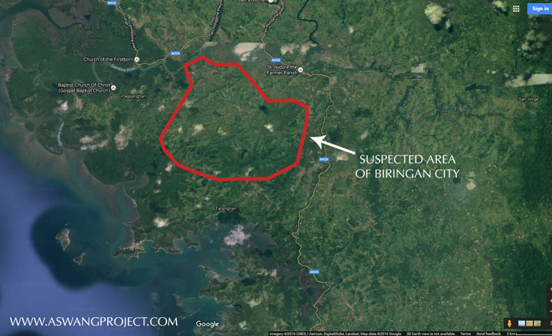

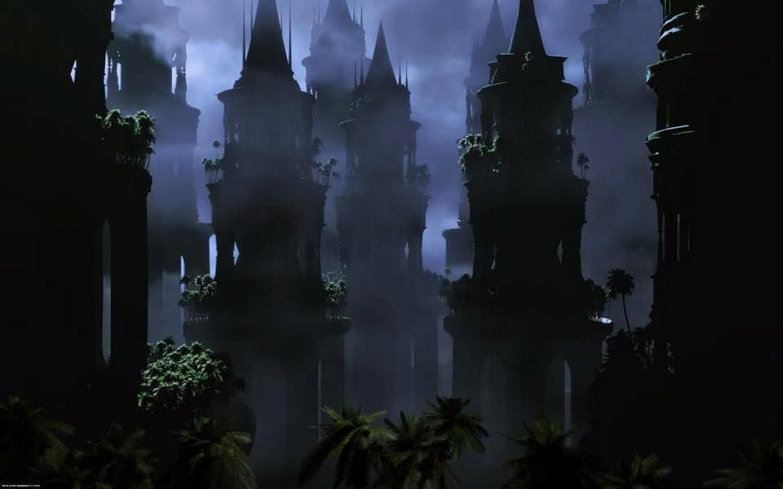

Biringan Research

{Biringan - isang waray na salita na ang ibig sabihin ay "hanapan ng mga nawawala"

Description: Isang black urban city na may matataas na gusaling punong puno ng mga ilaw na tila ay dinadaig ng mga super cities tulad nalang ng New York at Hong Kong.

Saan mahahanap: Pagitan ng Pagsanghan at Gandara sa Samar.

Paano mahanap: Mahahanap lang ang Biringan kung nais ng mga naninirahan dito ay ikaw ay imbitahin sa kanilang lungga.}

> https://youtu.be/FZjEFA5lij4?si=9qX4Fn7N94BZDWyZ

{"The legends of Biringan City take a chilling turn when the inhabitants are described. It is believed that everything they wear or eat is black. They look very similar to the local residents except they have no philtrum on their upper lip (the vertical groove between the base of the nose and the border of the upper lip).

"What further adds to the dark aura of the ethereal city are the other beliefs that coincide with those of the mythical beings of the Philippines. For instance, when there is a sudden unexplained death, it is believed that an engkanto has taken a fancy to that person and has abducted them into the realm of Biringan. Left behind is a lifeless body. This is not unlike the stories of the Batibat, or Duwende whose tales are also used to explain such incidents. It has also been rumoured that the body left behind is not actually the body of the abductee, but instead a banana tree log, or stump, with a spell cast to make it appear like the body. This is similar to the folktales of the Bal-Bal and Aswang, who also partake in such an activity." }

> <https://www.aswangproject.com/biringan-city/>

________________________

ENGKANTOS Dwelling in the Philippines

An Engkanto, according to folklore, is an environmental spirit that has a human form.

Engkantos occupy a space in the environment which is not openly accessible to us. However, this environment has portals; and there are certain schedules where they open and close. Those who would be able to get inside should also be able to get out before these portals close; lest, they will be trapped in there and would have to wait for the next schedule before they can come out.

Like humans, Engkantos also get old, sick and they can even die. They have the ability to cause ailments, depression and confusion among human beings. They can mislead travellers and kidnap those that they like or those they pity and bring them to their realm.

It is believed that if they become fond of you or if they want to help you, they will take you to their space and give you an ability that will make you powerful or wealthy. There are people who have been in coma or have lost their minds in many days who afterward claim that they were following strange beings to strange places. They are not even aware that they have been in such condition for a long time. Most of them thought that they had only been away for a while.

Oftentimes, engkantos are thought of as fallen angels because of their appearance and supernatural abilities. They look so good but they usually have 1 or 2 flaws. Take for example, a very beautiful woman with pointed ears and a very handsome man with the legs of a horse.

The Dwelling Place of Engkantos

There is a theory that the Earth we live in is made of 3 layers. There lower layer is the Underworld and it serves as the space of lower spirits. Now, they are not called lower spirits because they are lower in rank; but simply because they dwell in the Earth’slower layer. The middle layer is where we, human beings, dwell; and the third layer is otherwise known as Skyworld, the space of higher beings such as engkantos.

An illustration of 3 primitively dressed villagers stand near a fire in the middle of a forest while dozens of glowing humanoid figures move towards them.

Engkanto are environmental spirits in the Philippines: ART BY JBBallaran via DeviantArt

Engkantos and Human Beings

It is believed that some of these higher beings from the higher layer of the Earth called Skyworld used to mingle and interact with human beings. Some of them even had relationships with humans and they bore kids for them. This may be the reason why some of us have strong connections to higher spirits. Simply because some of our ancestors came from Skyworld.

Unfortunately, since human beings took advantage of the engkantos who were trying to help us then by teaching us technology and effective healing methods, they placed a veil between their dwelling place and ours. Nowadays, only chosen people can interact with them. They no longer make themselves very accessible to us because some of our ancestors became too dependent on them; asking for everything they need without working for it and borrowing stuff that they don’t return.

The Parallel Universe

The parallel universe may not really be another universe but just another layer of the Earth. That can be the Underworld or the Skyworld. Purportedly, the souls of human beings who have spiritual relatives from these 2 Earth layers will go there when they die.

<https://www.aswangproject.com/engkantos-dwelling-philippines/>

________________________

<https://www.aswangproject.com/engkanto-belief-an-essay-in-interpretation-by-francisco-r-demetrio-s-j/>

<https://www.aswangproject.com/philippine-lower-mythology/>

<https://www.aswangproject.com/why-is-salt-a-deterrent-against-engkantos-and-folkloric-spirits/>

**Maximo Ramos’ Works ("Creatures of Philippine Lower Mythology", "The Aswang Complex in Philippine Folklore") – Discuss engkantos, diwatas, and invisible cities like Biringan.**

**Damiana L. Eugenio’s "Philippine Folk Literature" series – Compiles myths, including engkanto encounters.**